**COMPUTATION OF STABILITY DELAY MARGINS**

System model of single-area LFC with EV aggregator:

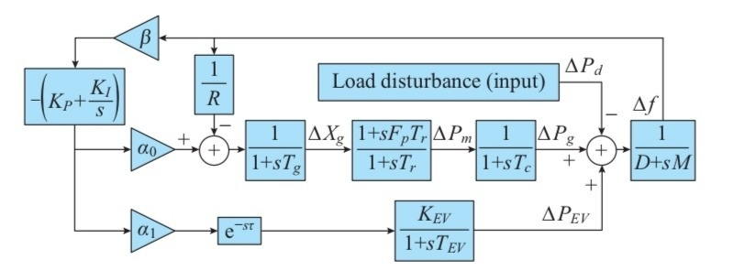

**G1**

+

**H1**

**G1**

**1**

**H2**

Let us consider,

$$G_{1}=1/{D+SM}$$

$$H_{1}= \frac{-[s[k_{p }βα_{0}R+1] +k_{I}βα_{0}R][1+SF_{p}T_{r}]}{Rs\left(1+ST_{g}\right)\left(1+ST_{c}\right)(1+ST_{r})}$$

$$H_{2}=\frac{-[k_{p }βα_{1}k_{ev }s+k_{2}βα_{1}k_{ev }]e^{-sτ}}{s+s^{2}T_{EV}}$$

M=8.8 ; D=1 $;$ $β=1$; ${ F}_{p}$ = $\frac{1}{6} ;$

$T_{EV}=0.1 ; T_{g }=0.2 ; { T}_{c}=0.3$; $T_{r}=12$;

$K_{ev }=1$; $K_{p }=0.2$; $K_{I }=0.6$;

$α_{0 }=0.8$; $α_{1 }=0.2 .$

By using **signal flow graph method**, we find the transfer function of the System model of single-area LFC with EV aggregator.

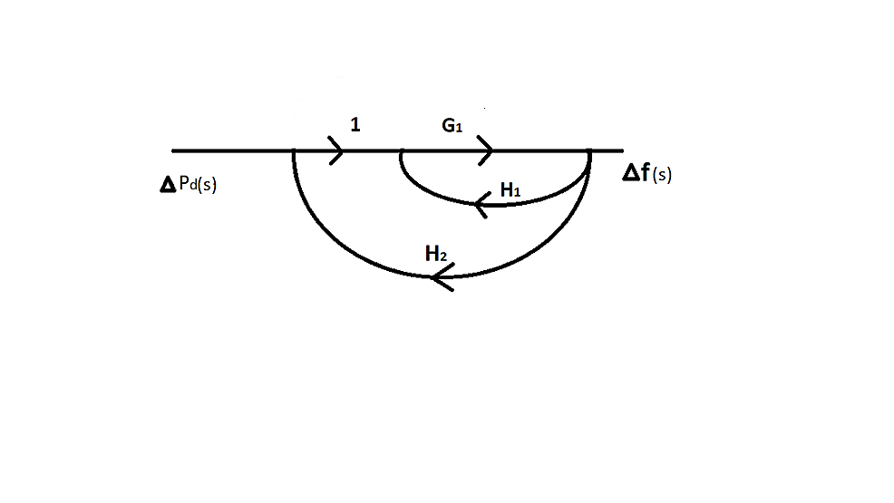

$$P_{1=}G_{1}{. ; ∆}_{1}=1-0=1.$$

$$L_{1=}G_{1}H_{1 . }; L_{2=}G_{1}H_{2} .$$

$∆ =1-\left[H_{1}+H_{2}\right]G_{1}$.

**Maison’s Gain formula:**

Transfer function = $\frac{P_{1}∆_{1}}{∆}$.

= $\frac{G_{1 }× 1}{1-G_{1}[H_{1}{+H}_{2}]}$

= $\frac{1/{D+SM}}{1+\frac{1}{D+SM}[\frac{\left[S\left(k_{p }βα_{0}R+1\right] +k_{I}βα_{0}R\right]\left[1+SF_{p}T_{r}\right]}{Rs\left(1+ST_{g}\right)\left(1+ST_{c}\right)\left(1+ST_{r}\right)}+\frac{-\left[k_{p }βα_{1}k_{ev }s+k_{2}βα_{1}k_{ev }\right]e^{-sτ}}{s+s^{2}T_{EV}}]}$

**= $\frac{\frac{1/{D+SM}}{\begin{aligned}Rs\left(1+ST_{g}\right)\left(1+ST_{r}\right)\left(1+ST_{C}\right)\left(D+SM\right)\left(s+s^{2}T_{EV}\right)]+[\left[s\left[k_{p }βα_{0}R+1\right] +k_{I}βα_{0}R\right]\left[1+SF_{p}T_{r}\right]\left[s+s^{2}T_{EV}\right]+Rs\left(1+ST_{g}\right)\left(1+ST_{c}\right) \\ (1+ST_{r})-[k_{p }βα_{1}k_{ev }s+k_{2}βα_{1}k_{ev }]e^{-sτ}\end{aligned}}}{\left(D+SM\right)\left(1+ST_{g}\right)\left(1+ST_{c}\right)\left(1+ST_{r}\right)(s+s^{2}T_{EV})RS}$**

The closed loop transfer function of the time-delayed load frequency control system relates **Δf(s)**, the incremental frequency variable (output variable) to load disturbance variable **Δ $P_{d}$ (s)** (input variable).

The closed loop transfer function is derived as follows:

G $\left(s\right)=\frac{∆f\left(s\right)}{∆P_{d\left(s\right)}}=\frac{N\left(s\right)}{P\left(s\right)+Q\left(s\right)e^{-sτ}}$

**N(s) = $n_{5}s^{5}$ + $n_{4}s^{4}$ + $n_{3}s^{3}$ + $n_{2}s^{2}$ + $n_{1}s^{1}$ + $n_{0}$**

**= $s^{5}$** [${RT}_{EV}T_{R}T_{c}T_{g}]+ s^{4} [R$ [ $T_{g}T_{R}T_{EV}$ + $T_{R}T_{c}T_{EV}$ + $T_{c}T_{g}T_{EV}+ T_{R}T_{c}T_{g}]$ $+ s^{3}[R$ [ $T_{g}T_{EV}$ + $T_{R}T_{EV}$ + $T_{c}T_{EV}+T_{R}T_{g}+T_{R}T_{c}+T_{c}T_{g}]]$ ${ + s}^{2} [R$ [ $T_{R}$ + $T_{g}$ + $T_{c}+$ $T_{EV}]]$ +**s** [R]

**P(s) = $p_{6}s^{6}+ { p}_{5}s^{5}$ + $p_{4}s^{4}$ $p_{3}s^{3}$ + $p_{2}s^{2}$ + $p_{1}s^{1}$ + $p_{0}$**

**= $s^{6}\left[MRT_{g}T_{r}T_{c}T_{EV}\right] + s^{5}\left[DRT_{g}T_{r}T_{c}T_{EV} + MR (T_{g}T_{r}T_{c}+T_{r}T_{c}T_{EV}+{ T}_{g}T_{c}T_{EV}+ T_{g}T_{r}T_{EV})\right]$ + $s^{4}\left[DR(T_{g}T_{r}T_{c}+T_{r}T_{c}T_{EV}+T_{g}T_{c}T_{EV}+ T_{g}T_{r}T_{EV})+MR(T_{r}T_{c}+T_{g}T_{c}+T_{g}T_{r}+T_{g}T_{EV}+T_{r}T_{EV}+T_{c}T_{EV})\right]$ + ${ s}^{3}\left[DR(T_{r}T_{c}+T_{g}T_{c}+T_{g}T_{r}+T_{g}T_{EV}+{ T}_{r}T_{EV}+T_{c}T_{EV})+MR\left(T_{r}+ T_{c}+T_{g}+T_{EV}\right)+F_{p}T_{r}T_{EV}+α_{0}βRK_{p}F_{p}T_{r}T_{EV}\right]$** + $s^{2} \left[DR\left(T_{r}+T_{c}+ T_{g}+T_{EV}\right)+MR+F_{p}T_{r}+T_{EV}+α_{0}βR\left(K_{p}T_{EV}+K_{p}T_{r} F_{p}+ K_{1}F_{p}T_{r} T_{EV} \right)\right]$**+ $s^{1}$ $\left[DR+1+ α_{0}βR(K_{p}+k_{1}T_{EV}+k_{1}T_{r}F_{p}\right]$ + $\left[α_{0}βRK_{1}\right]$**

**Q(s) = $q_{4}s^{4}$ + $q_{3}s^{3}$ + $qs^{2}$ + $q_{1}s^{1}$ + $q_{0}$**

= ${ s}^{4}$ $\left[α_{1}βRK_{EV}K_{p}T_{g}T_{r}T_{c}\right]$**+ $s^{3}$ $\left[α_{1}βRK_{EV}\left(K_{p}T_{r}T_{c}+K_{p}T_{g}T_{c}+ K_{p}T_{g}T_{r}+K_{1}T_{g}T_{r}T_{c}\right)\right]$ + $s^{2}$ $\left[α_{1}βRK_{EV}\left(K_{p}T_{c}+K_{p}T_{g}+K_{p}T_{r}+{ K}_{1}T_{r}T_{c}{+K}_{1}T_{g}T_{c}+K_{1}T_{r}T_{g}\right)\right]$ + $s^{1} \left[α_{1}βRK_{EV}\left(K_{p}+K_{1}T_{c}+K_{1}T_{r}+{ K}_{1}T_{g}\right)\right]$ + $\left[ α_{1}βRK_{EV}K_{1}\right]$**

For stability region and delay margin computations, it is necessary to obtain the characteristic equation of the single area LFC-EV system.

The characteristic equation of the single area LFC-EV system:

$∆(s,τ$**) $=P\left(s\right)+Q(s)e^{-sτ}$**

$∆(s,τ$**) $=$ $\left[s^{6}\left[MRT_{g}T_{r}T_{c}T_{EV}\right] + s^{5}\left[DRT_{g}T_{r}T_{c}T_{EV} + MR (T_{g}T_{r}T_{c}+ T_{r}T_{c}T_{EV}+ T_{g}T_{c}T_{EV}+ T_{g}T_{r}T_{EV})\right]+s^{4}\left[DR(T_{g}T_{r}T_{c}+T_{r}T_{c}T_{EV}+T_{g}T_{c}T_{EV}+ T_{g}T_{r}T_{EV})+MR(T_{r}T_{c}+T_{g}T_{c}+T_{g}T_{r}+T_{g}T_{EV}+T_{r}T_{EV}+T_{c}T_{EV})\right] + { s}^{3}\left[DR(T_{r}T_{c}+T_{g}T_{c}+T_{g}T_{r}+T_{g}T_{EV}+{ T}_{r}T_{EV}+T_{c}T_{EV})+MR\left(T_{r}+ T_{c}+T_{g}+T_{EV}\right)+F_{p}T_{r}T_{EV}+α_{0}βRK_{p}F_{p}T_{r}T_{EV}\right] +s^{2} \left[DR\left(T_{r}+T_{c}+ { T}_{g}+T_{EV}\right)+MR+F_{p}T_{r}+T_{EV}+α_{0}βR\left(K_{p}T_{EV}+K_{p}T_{r} F_{p}+ { K}_{1}F_{p}T_{r} T_{EV} \right)\right] + s^{1} \left[DR+1+ α_{0}βR(K_{p}+k_{1}T_{EV}+k_{1}T_{r}F_{p}\right] + \left[α_{0}βRK_{1}\right]\right]$ + $\left[s^{4} \left[α_{1}βRK_{EV}K_{p}T_{g}T_{r}T_{c}\right] + s^{3} \left[α_{1}βRK_{EV}\left(K_{p}T_{r}T_{c}+{ K}_{p}T_{g}T_{c}+ K_{p}T_{g}T_{r}+K_{1}T_{g}T_{r}T_{c}\right)\right] + s^{2} \left[α_{1}βRK_{EV}\left(K_{p}T_{c}+K_{p}T_{g}+{ K}_{p}T_{r}+T_{r}T_{c}{+K}_{1}T_{g}T_{c}+K_{1}T_{r}T_{g}\right)\right] + s^{1} \left[α_{1}βRK_{EV}\left(K_{p}+K_{1}T_{c}+K_{1}T_{r}+{ K}_{1}T_{g}\right)\right] + \left[ α_{1}βRK_{EV}K_{1}\right]\right]$ $e^{-sτ}$.**

The roots of the characteristic equation are:

$0.05765s^{6}+ 1.06734s^{5}$**+ $6.02351s^{4}$ $11.6329s^{3}$ + $7.20563s^{2}$ + $6.2595s^{1}$ + 1.145 = 0**

**S = - 9.90431**

**S = - 5.36025**

**S = - 2.84345**

**S = - 0.221403**

**S = - 0.0923932 $±$ 0.765317i**

The necessary condition for the single-area LFC-EV system to be asymptotically stable is that all the roots must be in the left half of the s-plane. In consideration of the single delay, the delay margin computation can be done by finding values of τ* for which has roots on the jω-axis. For some finite value of τ*, the characteristic polynomial of Δ (s, τ*) =0 has a root on the imaginary axis at s= j $w_{c}$, the equation of Δ (-s, τ*) =0 will also have the same root on the imaginary axis for the same value of τ* and $w_{c}$ due to the complex conjugate symmetry of complex roots. That means s=jωc will be a common root of the following equation:

$∆(jω_{c},,τ^{*}$**) $= P\left(jω_{c}\right)+Q(jω_{c})e^{-jw_{c}τ^{*}}$ =0**

$∆\left(-jω_{c},τ^{*}\right)= P\left(-jω_{c}\right)+Q(-jω_{c})e^{jw_{c}τ^{*}}=0$

By eliminating the exponential terms between the above two sub-equations, the following augmented polynomial is obtained:

$W(ω_{c}^{2}$) = P ( $jω_{c})$ P ($-jω_{c})-Q(jω_{c}) Q(-jω_{c})=0$

**P(s)** = $p_{6}s^{6}+p_{5}s^{5}{+p}_{4}s^{4}+p_{3}s^{3}+p_{2}s^{2}+p_{1}s^{1}{+p}_{0.}$

**P(-s)** = ${ p}_{6}s^{6}-p_{5}s^{5}-$ $p_{4}s^{4}-p_{3}s^{3}-p_{2}s^{2}$ $-p_{1}s^{1}{-p}_{0}$.

**P(s) $×$ P(-s)** = $s^{12}p_{6}p_{6}-$ $s^{11}p_{5}p_{6}$ + ${+s}^{10}p_{4}p_{6}-s^{9}p_{3}p_{6}+s^{8}p_{2}p_{6}-s^{7}p_{1}p_{6}$ + $s^{6}p_{6}p_{0}+s^{11}p_{5}p_{6}+s^{10}p_{5}p_{5}+s^{9}p_{5}p_{4}-s^{8}p_{5}p_{3}$ + $s^{7}p_{5}p_{2}-s^{6}p_{5}p_{1}+s^{10}p_{6}p_{4}-s^{9}p_{5}p_{4}+s^{8}p_{4}p_{4}{-s}^{7}p_{3}p_{4}+s^{6}p_{2}p_{4}-s^{5}p_{1}p_{4}{+s}^{4}p_{0}p_{4}+s^{9}p_{3}p_{6}-s^{8}p_{3}p_{5}+s^{7}p_{3}p_{4}-s^{5}p_{3}p_{2}-s^{4}p_{3}p_{1}+s^{3}p_{3}p_{0}+s^{8}p_{6}p_{2}-s^{7}p_{5}p_{2}$ + $s^{6}p_{4}p_{2}-s^{5}p_{3}p_{2}-s^{4}p_{2}p_{2}{-s}^{3}p_{1}p_{2}+s^{2}p_{0}p_{2}{+s}^{7}p_{6}p_{1}-s^{6}p_{5}p_{1}+s^{5}p_{4}p_{1}-s^{4}p_{3}p_{1}+s^{3}p_{2}p_{1}-s^{2}p_{1}p_{1}$ $+s^{1}p_{0}p_{1}+s^{6}p_{6}p_{0}$ $-$ $s^{5}p_{5}p_{0}{+s}^{4}p_{4}p_{0}-s^{3}p_{3}p_{0}+s^{2}p_{2}p_{0}-s^{1}p_{0}p_{1}{+p}_{0}^{2}$.

**P(s) $×$ P(-s)** = $s^{12}p_{6}p_{6}-s^{10}$ ($p_{5}^{2}-2p_{4}p_{6})+ s^{8}$ ($p_{4}^{2}+2p_{2}p_{6}-2p_{5}p_{3})- s^{6}$ ($p_{3}^{2}+2p_{2}p_{4}+2p_{5}p_{1}-2p_{6}p_{0})+s^{4}$ ( $p_{2}^{2}$ $-2p_{3}p_{1}+2p_{4}p_{0})- s^{2}$ ($p_{1}^{2}-2p_{2}p_{0})+ p_{0}^{2}.$

**Q(s)**  = $q_{4}s^{4}{+q}_{3}s^{3}+q_{2}s^{2}+q_{1}s^{1}+q_{0}$.

**Q($-$ s)** = $q_{4}s^{4}$ ${-q}_{3}s^{3}-$ $q_{2}s^{2}-$ $q_{1}s^{1}-q_{0}$.

**Q(s) $×$ Q(-s)**= $s^{8}q_{4}^{2}-s^{7}q_{4}q_{3}+s^{6}q_{4}p_{2}-s^{5}q_{4}q_{1}+s^{4}q_{3}q_{0}+s^{7}q_{3}q_{4}-s^{6}q_{3}q_{3}+s^{5}q_{3}q_{2}-s^{4}q_{3}q_{1}+s^{3}q_{3}p_{0}+s^{6}q_{2}q_{4}-s^{5}q_{3}q_{2}{ -s}^{4}q_{2}q_{2}-s^{3}q_{2}q_{1}+s^{2}q_{2}q_{0}+s^{5}q_{1}q_{4}{-s}^{4}q_{3}q_{1}+s^{3}q_{2}q_{1}+s^{2}q_{2}q_{0}-s^{1}q_{1}q_{0}+q_{0}^{2}.$

**Q(s) $×$ Q(-s) = ${ s}^{8}q_{4}^{2}-s^{6}$**($q_{3}^{2}-2q_{4}q_{2})+s^{4}(q_{2}^{2}+2q_{3}q_{0}+2q_{3}q_{1}$) $-s^{2}$

$(q_{1}^{2}{-2q}_{2}q_{0}){+q}_{0}^{2}$.

Substitute **s = j $ω_{c},$**

**P(j $ω$) $×$ P(-j $ω$)- Q(j $ω$) $×$ Q(-j $ω$) = $ω_{c}^{12}p_{6}^{2}-ω_{c}^{10}(p_{5 }^{2}-2p_{6}p_{4}$** )+ $ω_{c}^{8}$ ($p_{4}^{2}$ + $2p_{2}p_{6}-2p_{5}p_{3})- ω_{c}^{6}$ ($p_{3}^{2}$ + $2p_{2}p_{4}+2p_{5}p_{1}-2p_{6}p_{0})+ω_{c}^{4}$ ($p_{2}^{2}$- $2p_{3}p_{1}+2p_{4}p_{0})$- $ω_{c}^{2}$ ($p_{1}^{2}$- $2p_{2}p_{0})+ p_{0}^{2}$- ${ ω}_{c}^{8}q_{4}^{2}+ω_{c}^{6}\left(q_{3}^{2}-2q_{4}q_{2}\right)-ω_{c}^{4}(q_{2}^{2}+2q_{3}q_{0}-2q_{3}q_{1}$) + $ω_{c}^{2}(q_{1}^{2}$- ${2q}_{2}q_{0})$- $q_{0}^{2}$

By substituting the polynomials of P( $jω_{c}),$ P($-jω_{c}),Q(jω_{c})$ and $Q(-jω_{c})$ into the augmented polynomial $W(ω_{c}^{2}$) of can be represented as

W($ω_{c}^{2})= t_{12}ω_{c}^{12}+ t_{10}ω_{c}^{10}+t_{8}ω_{c}^{8}+t_{6}ω_{c}^{6}+t_{4}ω_{c}^{4}+t_{2}ω_{c}^{2}+t_{0}=0$.

${ t}_{12}=p_{6}^{2} .$

${ t}_{10}=p_{5}^{2}-$ 2

+ 2– .

.

+ .

.

= 0.05765 ; $q_{4}=0.05497 ; t_{12}=$ 0.003323

${ p}_{5}$ = $1.06734$; $q_{3}=$ 0.62764 $; { t}_{10}=$ 0.4510

$p_{4}=5.96854{ ; q}_{2}=$ 2.33573 ; $t_{8}=$ 12.6955

${ p}_{3}$ = $11.0053{ ; q}_{1}=$ $2.9395$; $t_{6}=$ 69.828

${ p}_{2 }$ = $4.8699 ; q_{0}=$ 0.2290 ; $t_{4}=$-40.217

${ p}_{1}$ = $3.320 ; t_{2}=$-5.470

${ p}_{0}$ = $0.916 ; t_{0}=$ 0.78661

**W ($ω_{c}^{2}$) = 0**

**W ($ω_{c}^{2}$) = $0.00323ω_{c}^{2}$** +0.451 $ω_{c}^{2}$ +12.6955 $ω_{c}^{2}+69.828ω_{c}^{2}-40.217ω_{c}^{2}$ ­ - 5.47 $ω_{c}^{2}$ +0.786615=0

$ω_{c}^{2}$ = −103.77

$ω_{c}^{2}$ = −28.3095

$ω_{c}^{2}$ = −8.06205

$ω_{c}^{2}$ = −0.184679

$ω_{c}^{2}$**= 0.091843**

$ω_{c}^{2}$**= 0.606242**

The real positive roots are $ω_{c}$ **= 0.3030561** and $ω_{c}$**= 0.7786154.** Calculating the delay margin for each positive root and the minimum of those is taken as the system delay margin $τ^{*}$.

$τ^{*}$**= $\frac{1}{ω_{c}}$ arctan($\frac{a_{9}ω_{c}^{9}+a_{7}ω_{c}^{7}+a_{5}ω_{c}^{5}+a_{3}ω_{c}^{3}+a_{1}ω_{c}^{1}}{a_{10}ω_{c}^{10}+a_{8}ω_{c}^{8}+a_{6}ω_{c}^{6}+a_{4}ω_{c}^{4}+a_{2}ω_{c}^{2}+a_{0}})$.**

Where $a_{10}$ = ${-p}_{6}q_{4}$; $a_{10}$ = ${-p}_{6}q_{3}+p_{5}q_{4}$;

$a_{8}$ = $p_{6}q_{2}-p_{5}q_{3}+p_{4}q_{4}$;

$a_{7}$ = $p_{6}q_{1}-p_{5}q_{2}+p_{4}q_{3}$– $p_{3}q_{4}$;

$a_{6}$ = $-p_{6}q_{0}+p_{5}q_{1}-p_{4}q_{2}$– $p_{3}q_{3}-p_{2}q_{4}$;

$a_{6}$ = $+p_{6}q_{0}+p_{5}q_{1}-p_{4}q_{2}$ + $p_{3}q_{3}-p_{2}q_{4}$;

$a_{5}$ = $p_{5}q_{0}- p_{4}q_{1}+p_{3}q_{2}$- $p_{2}q_{3}+p_{1}q_{4}$;

$a_{4}$ = - $p_{3}q_{1}+ p_{2}q_{2}-p_{1}q_{3}$ + $p_{0}q_{4}$;

$a_{3}$ = - $p_{3}q_{0}+ p_{2}q_{1}-p_{1}q_{2}$- $p_{0}q_{3}$;

$a_{2}$ = - $p_{2}q_{0}+ p_{1}q_{1}-p_{0}q_{2}$;

$a_{1}$ = $p_{1}q_{0}- p_{0}q_{1}$;

$a_{1}$ = $p_{0}q_{0}$

$p_{6}$ = 0.05765 ; $q_{4}=0.05497 .$

${ p}_{5}$ = $1.06734$; $q_{3}=$ 0.62764 $.$

$p_{4}=5.96854{ ; q}_{2}=$ 2.33573 .

${ p}_{3}$ = $11.0053{ ; q}_{1}=$ $2.9395$.

${ p}_{2 }$ = $4.8699 ; q_{0}=$ 0.2290 .

${ p}_{1}$ = $3.320 ;$

${ p}_{0}$ = $0.916 ;$

$ω_{c}$ = 0.3030561.

$ω_{c}$ = 0.7786154.

The stability delay margin $τ^{*}=0.60185 s$ for given $K_{p }=0.2$; $K_{I }= 0.6$; $α_{0 }=0.8$; $α_{1 }=0.2 ;ω_{c}$ = 0.3030561.

**DELAY DEPENDANT STABILITY MARGIN:**

- STABILITY DELAY MARGIN (s)

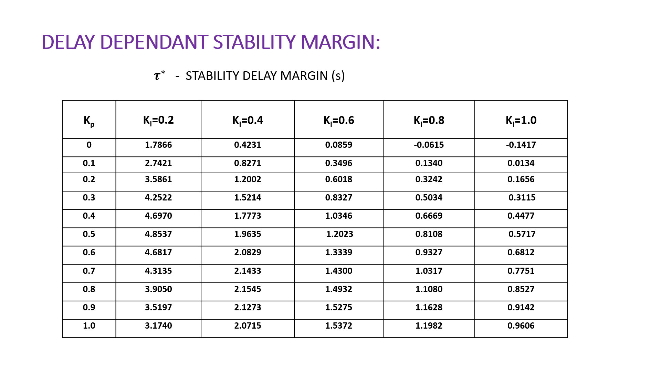

|  |  |  |  |  |  |
| --- | --- | --- | --- | --- | --- |
| **Kp** | **KI=0.2** | **KI=0.4** | **KI=0.6** | **KI=0.8** | **KI=1.0** |
| **0** | **1.7866** | **0.4231** | **0.0859** | **-0.0615** | **-0.1417** |
| **0.1** | **2.7421** | **0.8271** | **0.3496** | **0.1340** | **0.0134** |
| **0.2** | **3.5861** | **1.2002** | **0.6018** | **0.3242** | **0.1656** |
| **0.3** | **4.2522** | **1.5214** | **0.8327** | **0.5034** | **0.3115** |
| **0.4** | **4.6970** | **1.7773** | **1.0346** | **0.6669** | **0.4477** |
| **0.5** | **4.8537** | **1.9635** | **1.2023** | **0.8108** | **0.5717** |
| **0.6** | **4.6817** | **2.0829** | **1.3339** | **0.9327** | **0.6812** |
| **0.7** | **4.3135** | **2.1433** | **1.4300** | **1.0317** | **0.7751** |
| **0.8** | **3.9050** | **2.1545** | **1.4932** | **1.1080** | **0.8527** |
| **0.9** | **3.5197** | **2.1273** | **1.5275** | **1.1628** | **0.9142** |
| **1.0** | **3.1740** | **2.0715** | **1.5372** | **1.1982** | **0.9606** |